Sion Mills Primary School

ACCEPTABLE USE POLICY
FOR MOBILE PHONES
& OTHER ELECTRONIC DEVICES

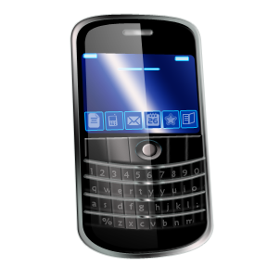
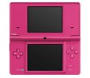

Signed by Principal: 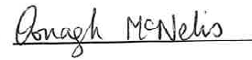
Date ratified by Board of Governors: 20/09/2022
Signed by Chair of Governors: 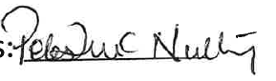
Next review date: September 2024

INTRODUCTION

Sion Mills PS recognises that pupils regularly use mobile phones and other electronic devices and that many parents wish their children to carry mobile phones to enhance their safety on journeys to and from school. Sion Mills PS aims to develop a culture of responsible use of mobile phones and other electronic devices by pupils.

Sion Mills PS further recognises that there are many benefits and learning opportunities to be gained from the use of technology such as mobile phones and electronic devices. However, the increasing technical sophistication of these telephones and electronic devices raises issues and challenges which the school management must address.
Research has shown that some pupils experience bullying through the use of text and picture messaging via mobile telephones and other electronic devices.

In order to develop a culture of responsible use the following steps are taken:
- There is an E-Safety policy;
- Pupils and staff sign an annual contract agreeing to acceptable use of IT
- Expert speakers are invited to provide age appropriate presentations on internet safety;
- Support is sought form NSPCC and other agencies;
- Parental workshops are provided

GUIDANCE REGARDING PUPILS
Pupils are advised that mobile telephones and other electronic devices should not be brought to school, including before/after school sessions, as the school is not liable for the theft, loss or damage of these.
If a parent requires their child to bring a mobile phone to enhance their safety after school, please contact their teacher or the principal, Mrs McNelis. Completion of a permission form will be required.
Pupils and parents are reminded that in cases of an emergency, the school office remains the appropriate point of contact.
GUIDANCE FOR PARENTS

While we would prefer parents not to use their mobile phones while on the school premises, we recognise that this would be impossible to regulate and that many parents see their phones as essential means of communication at all times. We therefore ask that parents’ usage of mobile phones, whilst on the school site is courteous and appropriate to the school environment.
Due to Safeguarding and Child Protection procedures all photos and/or videos may only be taken by school staff or authorised photographer.

GUIDANCE FOR STAFF

Staff use of mobile phones and electronic devices during their working school day should be: outside of their contact time and not in the presence of pupils unless agreed with the Principal;

Mobile phones and electronic devices should be switched off and left in a safe place during lesson times. The school will not take responsibility for items that are lost or stolen;

Staff will not contact pupils or parents from their personal mobile phones, or give their mobile phone number to parents unless in special circumstances;

Staff will never send to, or accept from colleagues or pupils, texts or images that could be viewed as inappropriate;

Mobile phone cameras; if a member of staff has occasion to use their mobile phone camera to photograph a pupil(s), for educational purposes only, these images should be uploaded to a c2k device as soon as possible thereafter and deleted from their personal mobile phone. Staff should adhere to the Sion Mills Primary School E-Safety and Safeguarding & Child Protection policies principles and practices in all instances.
SANCTIONS
Inappropriate use of mobile phones or other electronic devices will be regarded as a breach of discipline and dealt with according to staff Greivance Policy or Positive Behaviour Policy as appropriate.

